**WEEK – 9**

**1#** Write a C program that prints shape giving below by using nested loop:

1   
 1 2   
 1 2 3   
 1 2 3 4   
 1 2 3 4 5   
 1 2 3 4   
 1 2 3   
 1 2   
 1

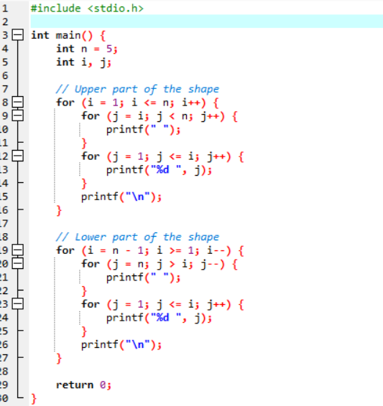

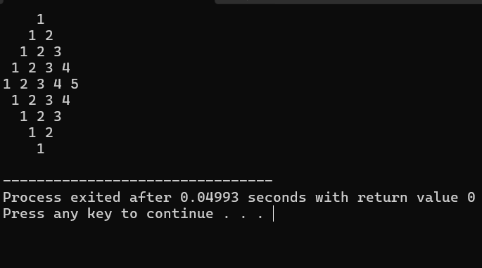

**2#** Write a C function to calculate the factorial of a number.

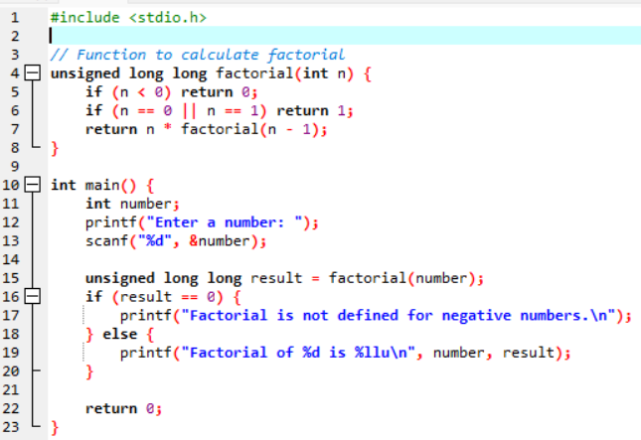

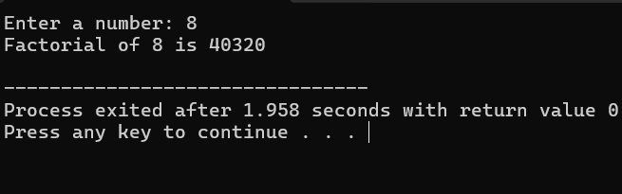

**3#** Write a C function to print Fibonacci series.

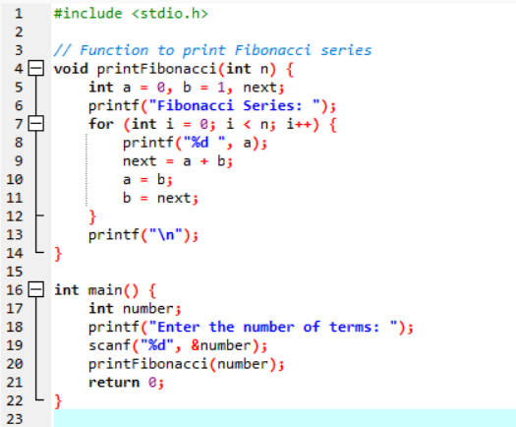

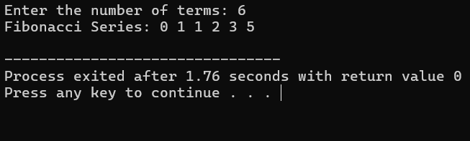

**4#** Write a C function to check whether a number is prime or not.

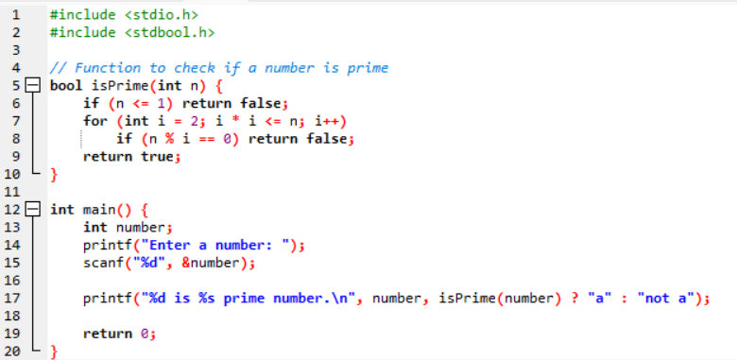

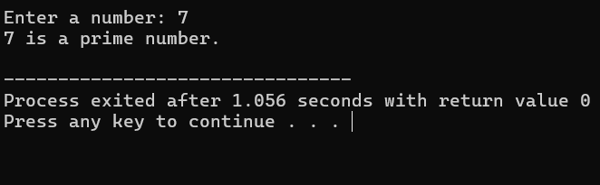  
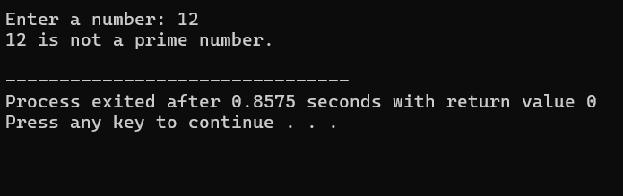

**5#** Write a C function to implement binary search.

